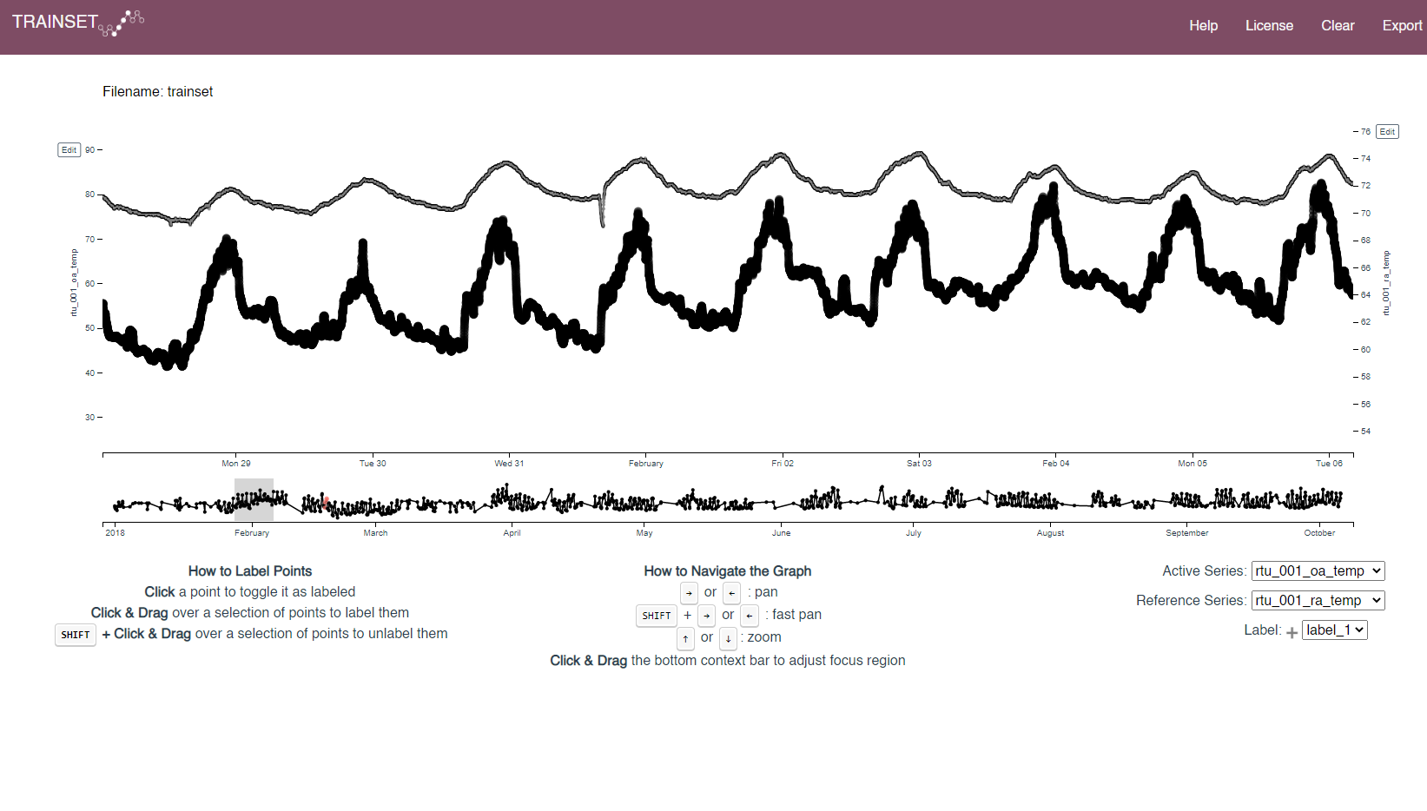

*Fig. 1. Weekly trend for outdoor air T (bold) and return air T for the original dataset.*

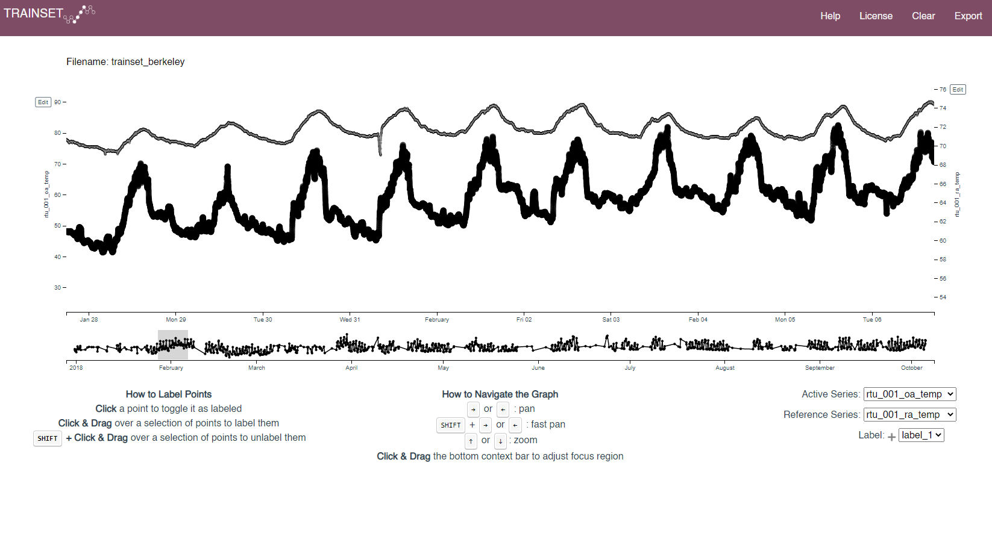

*Fig. 2. Weekly trend for outdoor air T (bold) and return air T for the adjusted dataset with Pacific time zone.*

For Fig 1 the peak of outdoor T is around midnight, which does not make sense (note that the starting of the day matches the name of the string). The same for the return air. It is suggested to convert all the data streams to pacific time zone.

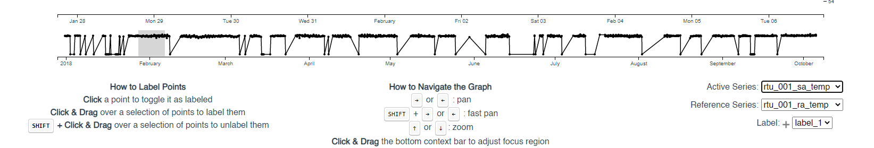

*Fig. 3. Schematized yearly trend for the supply air temperature.*

Differently from the other HVAC operational data, the supply air temperature has not been imputed. It is suggested to drop all the daily rows with zeros. Also the other imputed hvac operational data when the supply air temperature is missing have to be dropped.

It looks like the supply air temperature has almost always constant temperature and no variability.